Ashbourne House is a traditional, family run residential care home that offers 24/7 support for those suffering with dementia, mental health conditions, old age, physical disability, sensory impairment and eating disorders. Palliative, convalescent and respite care are also supported by our fully-qualified and friendly health care workers.

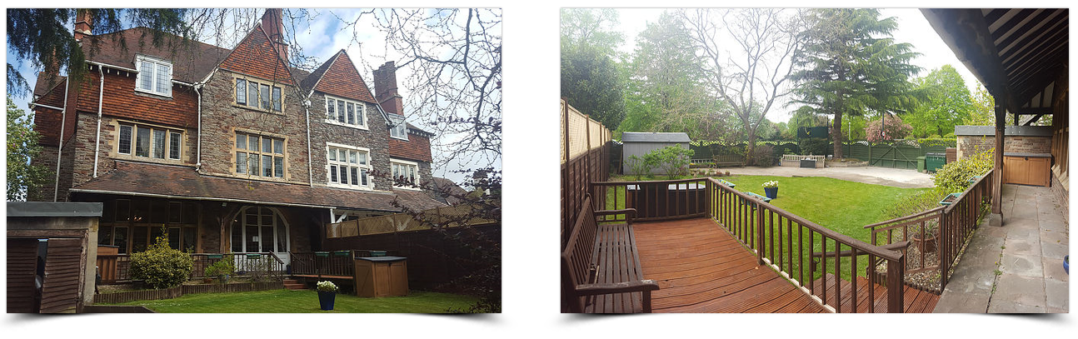

This elegant care home sits in a picturesque location in the Henleaze area of Bristol, overlooking The Downs and has been providing care in the communities of Westbury Park, Henleaze, Westbury on Trym, Redland and Stoke Bishop since 1980. It has a pleasant garden for residents to enjoy and is conveniently close to local shops and public transport. Ashbourne House Care Home has an excellent reputation with all working authorities, doctors’ surgeries and district nurses and is one of the longest running care homes registered in Bristol.
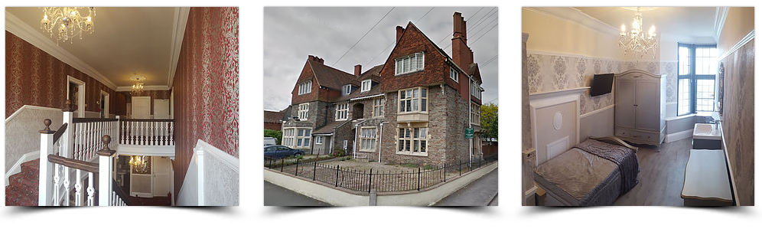

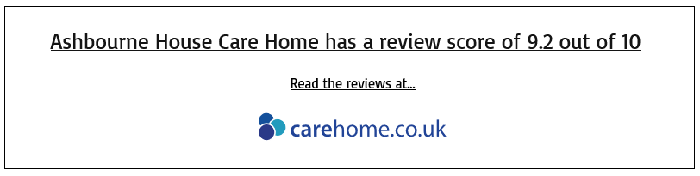

We understand the importance of respite care and the short-term, temporary relief it offers to people who care for family members. Many families take great pride in providing care to their loved ones, but sometimes the responsibility can be overwhelming without support. Respite at Ashbourne House Care Home provides a well-earned break for the family caregiver - offering an opportunity for them to recharge their own batteries - and can also offer a positive experience for the person receiving the care. It can also be a valuable break for older people too – a chance to meet new people, enjoy a change of scenery and maybe even try new activities and experiences.

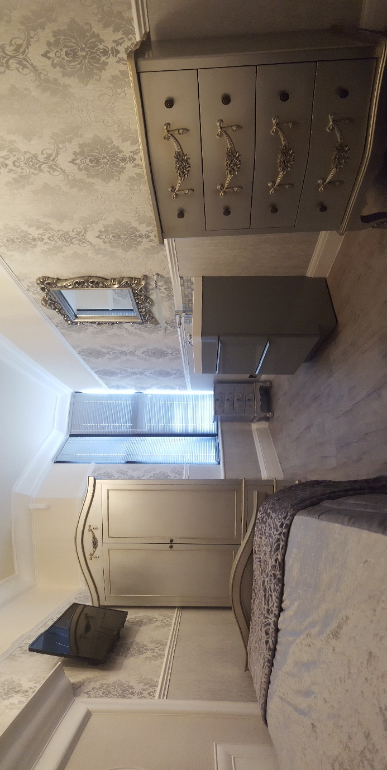

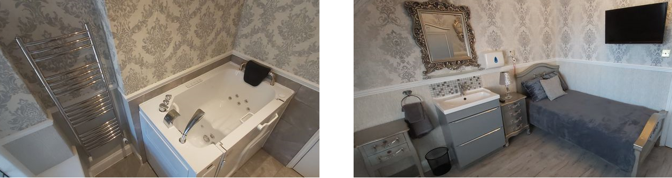

Contact Ashbourne House Care Home today and tell us how we can help with your convalescent, respite, dementia or long-term residential care requirements. Our friendly and compassionate health care workers will happily spend time with you, answering any questions you may have in relation to mental health conditions, old age, physical disability, sensory impairment and eating disorders. They will also check residency availability, guide you through the application process and will even arrange a tour of our care home.

Ashbourne House Care Home, 2 Henleaze Road, Bristol, BS9 4EX, Tel: 0117 321 6400
ashbourne-house@hotmail.com

